**KANTIPUR CITY COLLEGE**

**PUTALISADAK, KATHMANDU**

**GUIDELINES FOR PREPARATION OF PROJECT REPORT**

**Introduction**

Project report in this manual refers to a documented report of the process followed and the results of project conducted by a student in fulfillment of the requirements in bachelor degree. This report will outline the report format for project. These rules must be adhered strictly.

**Contents of Project report**

The Project Report should contain the items as outlined below and is to be presented in the order as listed. Details and specimens are shown in the appendices.

**Requirements for Report Writing:**

Your report should meet following standards:

**Font Name**: Times New Roman

**Left Margin**: 1.5 inch

**Right Margin**: 1.25 inch

**Top Margin**: 1.25 inch

**Bottom Margin**: 1.25 inch

**Header and Footer**: 0.5 inch

**Line Spacing**: 1.5

**Paragraph Spacing:** 18 pt

**Font Size**: 12 pt (for normal text)

Follow following standard for headings

* 1. **Heading1 (16 pt, Bold)** 
     1. **Heading2 (14 pt, Bold)** 
        1. **Heading3 (13 pt, Bold)** 
           1. **Heading4 (12 pt, Bold)**

**ARRANGEMENT OF CONTENTS:**

The sequence in which the project report material should be arranged and bound should be as follows:

|  |  |  |
| --- | --- | --- |
| 1. | Cover Page |  |
| 2. | Title Page |  |
| 3. | Topic Approval Sheet |  |
| 4. | Certificate from Supervisor |  |
| 5. | Acknowledgment |  |
| 6. | Project Abstract |  |
| 7. | Table of Contents |  |
| 8. | List of Figures (if any) |  |
| 9. | List of Tables (if any) |  |
| 10. | Abbreviations (if any) |  |
| 11. | Chapters |  |
| 12. | References |  |
| 14. | Appendices (if any) |  |

* *Students can add their own topics or sub-topics as per necessity.*
* *Justify the report for clean look at one side of page (preferably to right side).*

* *Please make sure not to use first person references (e.g., I, we, us) in the report. If self-reference is required, reference may be made to “the project members”*

**2.** **BINDING SPECIFICATIONS:**

Students have to submit **tape binding** of the report to the department at the time of report submission. **Hard binding** of the project report is to be submitted to the department after project defense for final semester.

**3.** **PREPARATION FORMAT:**

**Cover Page - Sample 1.**

**Title Page –** **Sample 2.**

**Topic Approval Sheet**

**Certificate from Supervisor – Sample 3.**

**Acknowledgment**

**Abstract –** It is a heart of the report. Abstract should be of 150 – 200 words synopsisof theproject report and it must clearly give the overview of the project including introduction with problem analysis, methods to solve and finally conclusion with result analysis (Avoid unnecessary things in abstract)

**Table of Contents –** The table of contents should list all material following it aswellas any material which precedes it. The title page and Certificate of approval should not be listed in the Table of Contents but the others pages excluding the chapters should be included in lower case Roman letters. One and a half spacing should be adopted for typing the matter under this head. A sample copy of the Table of Contents of the project report is given in **Appendix 1.**

**List of Figures –** The list should use exactly the same captions as they appear belowthe figures in the text. One and a half spacing should be adopted for typing the matter under this head **(Appendix 2)**.

**List of Tables –** The list should use exactly the same captions as they appear abovethe tables in the text. One and a half spacing should be adopted for typing the matter under this head **(Appendix 3)**.

**Abbreviations** – Abbreviation list should provide the details of the abbreviationsused in the report in alphabetical order. One and a half spacing should be adopted or typing the matter under this head **(Appendix 4)**.

**Page numbering -** The preliminary parts (Acknowledgement, Abstract, TableofContents, List of symbols, List of figure, List of Tables) are numbered in roman numerals (i, ii, etc.). The first page of the first chapter (Introduction) onwards will be numbered in Arabic numerals 1 2 3 etc. at the bottom, centered.

**Numbering sections, subsections, equations, figures etc. -** A word on numberingscheme used in the project is in order. It is common practice to use decimal numbering in the project. If the chapter number is 2, the section numbers will be 2.1, 2.2, 2.3 etc. The subsections in section 2.2 will be numbered as 2.2.1, 2.2.2 etc. Unless essential, it is not necessary to use numbers to lower levels than three stages.

Similarly, it is useful and convenient to number the figures chapter-wise. The figures in chapter 1 will be numbered as Figure 1.1: Figure Name, Figure 1.2: Figure Name etc. This helps you in assembling the figures and putting it in proper order. Similarly, the tables are also numbered as Table 1.1: Table Name, Table 1.2: Table Name etc. All figures and tables should have proper captions. Usually the **figure** **captions are written below the figure** and **table captions on top of the table**.

The same numbering scheme can be used for equations also. Only thing to be remembered is that references to the equations are made as Eqn (1.1), Eqn (1.2) etc.

**Chapters** – The main text will be divided into several chapters and each chaptermaybe further divided into several divisions and sub-divisions.

***Chapter 1: Introduction***

1. Project Introduction
2. Problem Statement,
3. Objectives of the project (in bullet),
4. Significance of the project,
5. Project Features,
6. Assignment of roles and responsibilities (who did what/ member-wise roles)
7. Documentation Organization

***Chapter 2: Existing Systems Overview***

(Overview of minimum 2 related existing systems and their pros and cons)

*Example:*

**System 1**

*System 1 Introduction,*

*System 1 Pros*

*System 1 Cons*

**System 2**

*System 2 Introduction,*

*System 2 Pros*

*System 2 Cons*

***Chapter 3: System Analysis***

1. System development model (which model fits the project and why)
2. Requirement specification
   1. Functional Requirements
   2. Nonfunctional requirements,

Example: Usability, Reliability & Availability, Performance, Security,

1. Feasibility Study (Technical, Economic, Schedule) {match this study with the SDLC model}

*Example of a planned Gantt chart*

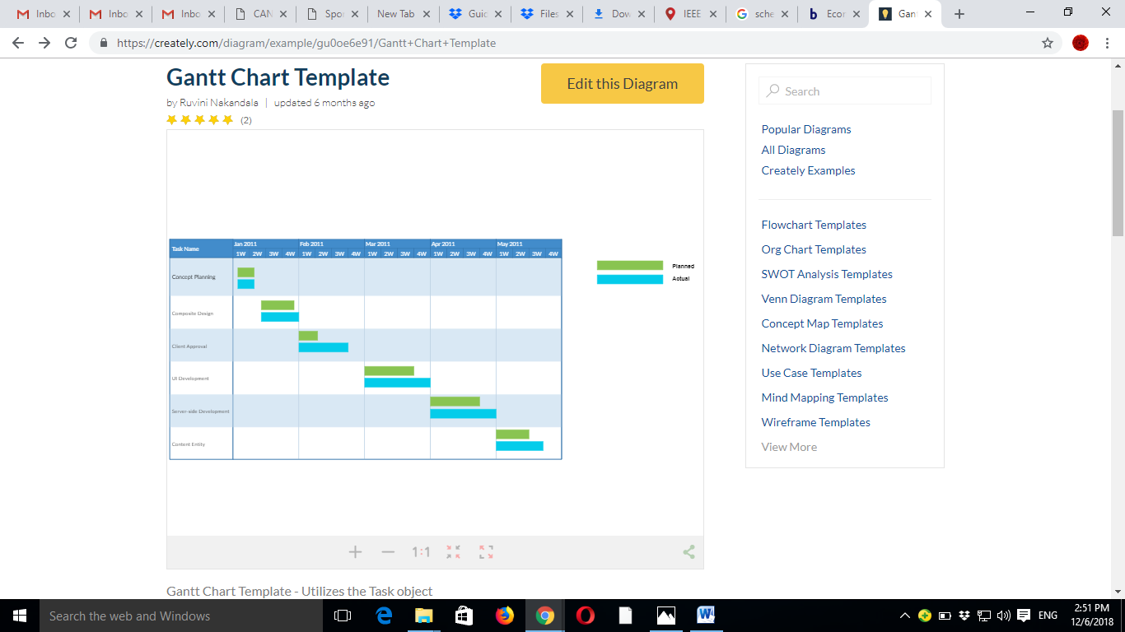

*Chapter 4: System Design*

1. System Architecture,(block diagram of the system and Working Procedure)
2. Context Diagram and Data Flow Diagram (DFD) (level 0, level 1 and level 2),
3. Use Case Diagram,
4. Sequence Diagram
5. Activity Diagram
6. Class Diagram
7. Database Design
   1. ER diagram
   2. Relational Data Structures (table name (fields))
   3. Data Dictionary (table_name, fields , types and description[primary key or foreign key etc.]))
8. UI/UX mechanisms

***Chapter 5: System Development and Implementation***

1. Programming platform, (Tools & technologies used)
2. Operating environment (minimum requirements for the system to run – software / hardware)
3. Testing and debugging, (test cases)
4. Implementation and result analysis

***Chapter 6: Conclusion and Future Enhancement***

* 1. Conclusion
  2. Limitations
  3. Future Enhancement

References

In APA format

Appendixes (Use when applicable)

Appendix 1: Screenshots

Appendix 2: Project Completion Gantt chart (should match with the schedule feasibility)

Appendix 3: User Manual

Appendix 4: Revenue Model

**List of References** –The reference material should include the author name,title,year in details as shown in **Appendix 6**. ***Please******do not mention the references of******the*** *general* ***websites in the report as far as applicable.***

**Appendices** – Appendices are provided to give supplementary information, which isincluded in the main text may serve as a distraction and cloud the central theme. Appendices should be numbered using Arabic numerals, e.g. Appendix 1, Appendix 2, etc. Tables and References appearing in appendices should be numbered and referred to appropriate places just as in the case of chapters.

**SAMPLE 1 (Cover Page)**

A project report

On

<< Project Name >>

Submitted in partial fulfillment of the requirement of Project – VI (Project Code)

of

Bachelor of Information Technology

**Submited to**

**<Logo>**

Purbanchal University

Biratnagar, Nepal

**Submitted By**

<Name> <University Symbol #>

<Name> <University Symbol #>

<Name> <University Symbol #>

**KANTIPUR CITY COLLEGE**

Putalisadak, Kathmandu

November 21, 2016

**SAMPLE 2 (Title Page after front page)**

A project report

On

<< Project Name >>

Submitted in partial fulfillment of the requirement of Project – VI (Project Code)

of

Bachelor of Information Technology

**Submited to**

Purbanchal University

Biratnagar, Nepal

**Submitted By**

<Name> <University Symbol #>

<Name> <University Symbol #>

**Project Supervisor**

**<<Name>>**

**<<Designation>>**

**KANTIPUR CITY COLLEGE**

Putalisadak, Kathmandu

November 21, 2016

**SAMPLE 3 (Certificate of Project Approval)**

**<To be provided by the department>**

**(Certificate from Supervisor)**

**<To be provided by the project supervisor>**

**SAMPLE 4 (Acknowledgement Sample)**

**ACKNOWLEDGEMENT**

**SAMPLE 5 (Abstract Sample)**

**ABSTRACT**

|  |  |  |  |  |  |  |
| --- | --- | --- | --- | --- | --- | --- |
|  | | **Appendix – 1: Table of Contents** | |  | |  |
|  | |  | |  |
|  | | **TABLE OF CONTENTS** | |  | | |  |
| **Acknowledgement** | | | | I | | |  |
| **Abstract** | | | | ii | | |  |
| **List of figures** | | | | Iii | | |  |
| **List of tables** | | | | **i**v | | |  |
| **List of symbols** | | | | v | | |  |
| **Abbreviation** | | | | vi | | |  |
| **Chapter 1: Introduction** | | | | 1 | | |  |
| 1.1 ………….. | | | | 1 | | |  |
| 1.2 …………. | | | | 2 | | |  |
| **1.2.1 ……….** | | | | **5** | | |  |
| **1.2.2.....** | | **. . . . . . . . . .** | | **12** | | |  |
| 1.2.2.1 ………. | | | | 19 | | |  |
| 1.2.2.2 . . . . . . . . . . | | | | 25 | | |  |
| 1.2.3 . | | . . . . . . . . . . . | | 30 | | |  |
| 1.3 . . . . . . . | | . . . .. . . . . . . | | 45 | | |  |
| 1.4 . . . . . . . | | . . . . . . . . . . . | | 58 | | |  |
| ……………………………….. | | | | 60 | | |  |
| **(Make other chapters in the same format)** | | | |  | | |  |
| **References** | | | | 100 | | |  |
| **Appendices** | | | | 102 | | |  |

|  |  |  |  |  |
| --- | --- | --- | --- | --- |
|  |  | **Appendix – 2: List of figures [SAMPLE]** |  |  |
|  |  | **LIST OF FIGURES** |  |  |
| **Figure Number** | | **Figure** | **Page No.** | |
| 1.1 | System Architecture | |  | 10 |
| 1.2 | System Block Diagram | |  | 12 |
| 2.1 | Context Diagram | |  | 14 |
| 3.1 | Use case Diagram | |  | 17 |

|  |  |  |  |  |
| --- | --- | --- | --- | --- |
|  |  | **Appendix – 3: List of tables [SAMPLE]** | |  |
|  |  | **LIST OF TABLES** |  |  |
| **Table Number** |  | **Table** | | **Page No.** |
| 1.1 | Software Requirement | | | 29 |
| 2.1 | Functions | | | 45 |

………………………………………………………………………………….

………………………………………………………………………………….

………………………………………………………………………………….

………………………………………………………………………………….

**Appendix – 4: Abbreviations**

**ABBREVIATIONS**

RAM Random Access Memory

HTML Hyper Text Markup Language

PHP PHP: Hypertext Processor

|  |  |  |
| --- | --- | --- |
| **Appendix – 5: Format of Body Text** |  |  |
|  |  |

**Chapter 1: INTRODUCTION**

## Background and Significance

|  |  |
| --- | --- |
| Appendix – 6: Table of Contents |  |

**References [SAMPLE]**

1. J. Tsai, P. Kelley, L. Cranor, and N. Sadeh, "Location-sharing technologies: Privacy risks and controls". In Research Conference on Communication, Information and Internet Policy (TPRC), 2009.
2. Bellavista P，Kupper A，Helal S．Location-based services: Back to the future［J］．IEEE Pervasive Computing，2008，7 (2): 85-89.